RESEARCH VOLUNTEERS WITH TRAUMATIC BRAIN INJURY AND FATIGUE WANTED
The Brain Injury Research Center at Mount Sinai Medical Center and Centre for Neuro Skills are seeking people who have had a traumatic brain injury (TBI) and fatigue. The research study will evaluate two different kinds of experimental light exposure to reduce fatigue. Compensation will be provided for your time.
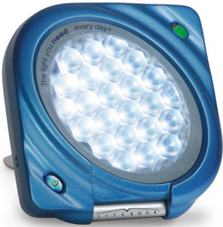

If interested, please call Lisa Kreber at
(661)872-3408 ext. 1513

